
YEDITEPE UNIVERSITY
FACULTY OF ENGINEERING

Detection of mycotoxins in dry fig using NIR scan with AI-based methods.
Emre Öztürk

GRADUATION PROJECT REPORT
Department of Electrical and Electronics Engineering

Supervisor
Asst. Prof. Dr. İpek Baz

ISTANBUL,2024

YEDITEPE UNIVERSITY
FACULTY OF ENGINEERING
Detection of mycotoxins in dry fig using NIR scan with AI-based methods.
by
Emre Öztürk
May,26, 2024, Istanbul

DEPARTMENT OF ELECTRICAL AND ELECTRONICS ENGINEERING

YEDITEPE UNIVERSITY

Signature of Author(s) …………………………………………………………………………
Department of Electrical and Electronics Engineering
Certified By …………………………………………………………………………
Project Supervisor, Department of Electrical and Electronics Engineering
Accepted By …………………………………………………………………………
Head of the Department of Electrical and Electronics Engineering

ACKNOWLEDGEMENTS
I would like to present my candid blessing to Asst. Prof. Dr. İpek Baz for their golden guidance and support throughout this research. Their expertise and encouragement have been crucial in the development of this study.
I am also grateful to Yeditepe University for providing the necessary resources and funding that made this research possible.
Furthermore, I would like to thank my colleagues Ali Baki Türköz for their helpful discussions and feedback. Their insights have significantly contributed to the improvement of this work.
Lastly, on this journey, I would like to sincerely thank my family and friends for their immense support and patience. Their encouragement has been a constant source of motivation.
Thank you all for your contributions and support.

May,26,2024
Emre Öztürk

Table of Contents

ACKNOWLEDGEMENTS 1
ABSTRACT 4
LIST OF SYMBOLS 5
ABBREVIATIONS 6
LIST OF FIGURES 7
LIST OF EQUATIONS 9
LIST OF TABLES 10
1. INTRODUCTION 11
1.1. Thesis Content 15
2. RESEARCH OBJECTIVE 16
3. LITERATURE REVIEW 19
4. DESIGN 21
4.1. Realistic Constraints and Conditions 21
4.2. Cost of the Design 23
4.2.1. Core Components 23
4.2.2. Supporting Hardware 23
4.2.3. Software and Calibration 23
4.2.4. Labor and Services 24
4.3. Engineering Standards 24
4.4. Details of the Design 25
5. METHODS 29
5.1. Preparation of the Dataset 30
5.1.1. Options for NIR 31
5.2. Spectroscopic Measurements 33
5.3. Training of Deep Learning Models 34
5.3.1. Pre-processing 35
5.3.2. Model Architecture 35
5.4. Integration and Testing on Raspberry Pi 38
6. RESULTS AND DISCUSSION 39
6.1. Different Trials 39
7. CONCLUSION 50
References 53
APPENDICES 57
Appendix A 57
Appendix B 59
Appendix C 66
Appendix D 67
APPENDİX E 69

ABSTRACT
Aflatoxins are one of the quite toxic secondary metabolites derived from polyketides produced by fungal species such as Aspergillus flavus, A. parasiticus, and A. nomius [1]. Products such as figs, corn, wheat, and walnuts can be infected, which cause a variety of problems and put human life and livestock into danger. Among the foods that are easily infected with aflatoxins is dried fig [2].
Currently, manual sorting of aflatoxin-contaminated figs is a common practice in fig production facilities. This method requires expertise and carries health risks associated with prolonged exposure to UV radiation. [3] Additionally, human error poses a risk of contaminated products reaching the market.
This study has two main objectives:
- Aflatoxin Data Collection with NIR Scan Nano: This study will collect data from aflatoxin-contaminated figs using NIR scan Nano spectroscopy. This data will be used to train an artificial intelligence model for aflatoxin detection.
- Artificial Intelligence-Based Autonomous Detection System: An autonomous system based on artificial intelligence will be developed to detect aflatoxins in dried figs. This system will utilize NIR scan Nano technology to automatically distinguish mycotoxin-contaminated figs.
An artificial intelligence-supported automation system will be established to reduce labor intensity and associated risks in current methods. This system will employ NIR scanning and nanotechnology to automatically detect aflatoxin-contaminated figs, thereby mitigating the risks of human error and exposure to UV radiation. The study aims to provide a safer and more effective alternative to current methods in dried fig processing facilities.
Keywords: Artificial Intelligence, Deep Learning, NIR scan Nano, Autonomous, Human Health

LIST OF SYMBOLS

$e^{y_{i}}=$ Probability of the output of the model.
$\sum_{j=1}^{n}{e^{y_{j}}}$= This is the output probability sum of the model.

ABBREVIATIONS
CNN: Convolutional Neural Network
OTA: Ochratoxin
AFB: Aflatoxin
NIR: Near-Infrared
EVM: Evaluation Module
Nano: Nanotechnology
R&D: Research and Development
FMs: Fumonisins
DON: Deoxynivalenol
WHO: World Health Organization
IARC: International Agency for Research on Cancer
AFB1: Aflatoxin B1
UV: Ultraviolet
RIA: Radioimmunoassay
ICA: Immuno-Affinity Column Assay
ATP: Adenosine Triphosphate
PCR: Polymerase Chain Reaction
GA: Genetic Algorithm
MIR: Mid-infrared Spectroscopy

LIST OF FIGURES
Figure 1 Schema of the Near-infrared (NIR) measuring process (Copyright © 2020 Spectroscopy Volume 35 Issue 11). 14
Figure 2 An NIR spectroscopy system consists of the following components: (1. Light Source; 2. Light Dispersion System; 3. Reflector; 4. Sample Holder/Detector Input; 5. Reflection Detector; 6. Transmission Detector; 7. Data Processing Analys (Copyright 2011 © from references 14). 16
Figure 3 A flow chart for the designed system. 25
Figure 4 DLP NIR scan Nano Evaluation Module (Copyright 2017 © from Texas Instruments, EVM User’s Guide). 29
Figure 5 The fig samples have different regions from which data are received (Copyright 2018 © from Ahmet Seçkin Bilgi 05/29). 30
Figure 6 Healthy fig example. 30
Figure 7 Fig example with aflatoxin. 31
Figure 8 Absorbance values of dried figs with aflatoxin. 31
Figure 9 Absorbance values of healthy dried figs. 32
Figure 10 Custom Box Design 32
Figure 11 Custom Box Design 33
Figure 12 Dried figs with Aflatoxin Absorbance graph. 34
Figure 13 Healthy fig absorbance graph. 34
Figure 14 Splitting the Data. 35
Figure 15 Batch Sizes 35
Figure 16 Pooling layer functions (Copyright 2021 © from Sedat Metlek, Vocational School of Technical Sciences). 37
Figure 17 Dropout Layer (Copyright 2016 © from Budhiraja Amar, Dropout in (Deep) Machine learning ). 38
Figure 18 Training and Validation Accuracy Graph 39
Figure 19 Training and Validation Loss Graph 39
Figure 20 Training and Validation Accuracy Graph 40
Figure 21 Training and Validation Loss Graph 40
Figure 22 Training and Validation Accuracy Graph 41
Figure 23 Training and Validation Loss Graph 41
Figure 24 Training and Validation Accuracy Graph 42
Figure 25 Training and Validation Loss Graph 42
Figure 26 Training and Validation Accuracy Graph 43
Figure 27 Training and Validation Loss Graph 43
Figure 28 Training and Validation Accuracy Graph 44
Figure 29 Training and Validation Loss Graph 44
Figure 30 Training and Validation Accuracy Graph 45
Figure 31 Training and Validation Loss Graph 45
Figure 32 Training and Validation Accuracy Graph 46
Figure 33 Training and Validation Loss Graph 46
Figure 34 Training and Validation Accuracy Graph 47
Figure 35 Training and Validation Loss Graph 47
Figure 36 Result of Raspberry Pi 48
Figure 37 Prediction of Raspberry Pi 49

LIST OF EQUATIONS
Equation 1 Convolution Layer 36
Equation 2 ReLU Activation Function 36
Equation 3 The SoftMax Classifier. 37

LIST OF TABLES
Table 1 Mycotoxins Overview 11
Table 2 Analytical Methods for Mycotoxin Detection 12
Table 3 Result of All Attempts 48

INTRODUCTION
Aspergillus type molds (A. Flavus, A. Paraciticus and A. Nominus) produce aflatoxin in agricultural products (e.g. Figs, hazelnuts, corn, almond, etc.). Mycotoxin contamination in both food and feed staple commodities is considered to be ineluctable due to the widespread occurrence of mycotoxin-producing fungi in the environment). More than 400 mycotoxins and their species structures have been identified. However, only a small portion of these substances is considered hazardous in relation to food and animal feed safety. These include aflatoxins (AFs), ochratoxin A (OTA), fumonisins (FMs), deoxynivalenol (DON).Table 1).
Mycotoxin | Abbreviation | Producing Fungi | Health Impact | Commonly Contaminated Commodities
Aflatoxins | Afs | Aspergillus spp. | Carcinogenic, liver damage | Peanuts, corn, cottonseed, tree nuts
Ochratoxin A | OTA | Aspergillus spp., Penicillium spp. | Nephrotoxic, carcinogenic | Cereals, coffee, dried fruits, wine
Fumonisins | FMs | Fusarium spp. | Esophageal cancer, neural tube defects | Corn and corn-based products
Deoxynivalenol | DON | Fusarium spp. | Vomiting, feed refusal, immunosuppression | Wheat, barley, corn

Table 1 Mycotoxins Overview
Among these mycotoxins, aflatoxins have plundered significant attention due to their high toxicity. Aflatoxin B1 (AFB1) has been designated as a Group 1 agent, indicating a strong carcinogenic risk to humans, by the IARC of the World Health Organization (WHO). It has been historically linked to liver cancer, and more recent studies have revealed its harmful impact on nutritional outcomes and its repressing effects. Some of the effects of mycotoxins are spinning, throwing up and , reduction in weight, nerve problems, change in the normal functioning of the heart as well as blood vessels, decreased immune response, bleeding problems which impair clotting, skin harmfulness, reduced ability to reproduce, destruction of blood forming organ. [4]
Dried figs are sensitive to aflatoxin (AF) contamination, and the natural existence of AF can be at high levels. The fruit structure, harvesting, drying, and storage can affect the occurrence of AF in dried figs, as well as their high sugar content. Moreover, due to their meaty skin which does not provide any protection AF contamination can occur easily. It is worth mentioning that the natural occurrence of AF in a single fig fruit can be very high, for example 4000 gμ/kg. The existence of AF in dried figs is considered a major threat to human health [5]. In addition, several mycotoxins may be delivered via diet to people and animals at once or combined to produce effects greater than the sum of their parts established with test of cells as well as other experiments. [6].
For ensuring consistency in measurements of congruity, it is vital to employ efficient analytical techniques for the detection and quantification of mycotoxins. Typically, analyzing mycotoxins involves extracting the toxins from the matrix and implementing a cleanup process to eliminate interfering elements, and detection and quantification using appropriate analytical instrumentation. The most common methods used for mycotoxin analysis are chromatographic systems coupled with highly sensitive detection systems such LC or HPLC coupled with FL, UV, or MS detectors. In many cases, overly high resolution necessitates extensive sample cleanup and purification, resulting in increased costs as well as tenuous and tedious protocols. [7].
Analytical Method | Description
Liquid Chromatography (LC) | Separates mycotoxins based on their chemical properties using a liquid mobile phase.
High-Performance Liquid Chromatography (HPLC) | A type of LC that utilizes high-pressure pumps to achieve faster separations and higher resolution.
Chromatography Coupled with... | LC or HPLC coupled with sensitive detectors.
Fluorescence (FL) | Detects mycotoxins based on their fluorescence properties when exposed to specific wavelengths of light.
Mass Spectrometry (MS)
  Identifies mycotoxins based on their mass-to-charge ratios, providing highly specific detection
Ultraviolet (UV) | Measures mycotoxins by their absorption of UV light at specific wavelengths.
Table 2 Analytical Methods for Mycotoxin Detection

Immunological-based methods are faster and simpler alternatives which use specific antibodies to trap target analytes and reporter molecules to produce detectable signals. Enzyme-linked immunosorbent assay (ELISA) is the most widely used in research and industry. Other techniques such as lateral flow detection (LFD), fluorescence polarization immunoassay (FPIA), radioimmunoassay (RIA), and immuno‐affinity column assay (ICA), use the same fundamentals based on immunology to develop simple, fast, and proper systems of mycotoxin analysis, even with their simplicity major drawbacks for such tests are the possibility of cross reactivity and their higher matrix dependence which lowers accuracy.
Additionally, there are high costs associated with development and commercial use. [8]. The latest generation of analytical techniques for mycotoxin analysis determine to operate these types of miniature systems, but to date, they have not succeeded in integrating the steps of extraction, purification, and detection directly within the system. Other traditional methods, i.e., the colony counting agar method, can also be used to identify contamination with mycotoxins and fungi but with a spread accepted internationally. Adenosine triphosphate (ATP) bioluminescence, polymerase chain reaction (PCR) method, and ELISA, biosensors and chromatographic methods [9]. These methods require more time for sample preparation and sometimes cause sample destruction. Therefore, it is necessary to create fast, easy, and reliable ways of determining mycotoxin infections and mycotoxin contamination. Therefore, there is a need to popularize and quickly use nondestructive methods of detecting fungal and mycotoxin diseases. [10].
There are different available methods for testing AFB1, such as HPLC, TLC, GC, and ELISA, which are known by many standards. [11]. Although HPLC and ELISA are highly accurate and sensitive for detecting AFB1 in peanuts, they come with various drawbacks. These methods require trained operators, and the use of potentially harmful chemicals is destructive, analyzing just one sample takes a lot of time, and the cost is high making them unsuitable for use in real-time measurements.
Hence, there is a necessity for a controlled, efficient, rapid, and non-destructive method to accurately classify aflatoxin-contaminated figs.
For their benefits namely less requirement for sample preparation, better precision levels, quicker detection speeds without harming the materials being scanned, and increasingly affordable sensors they are now considering various methods of instrumentation that do not rely on chemicals but can be used instead. Here are some that are discussed: near-infrared spectroscopy (NIRS) or mid-infrared spectroscopy (MIRS). There is also color imaging, hyperspectral imaging methods (HSI); among them fluorescence spectrometry. [12].
NIR spectroscopy is presently a very popular non-invasive and fast method used in detecting fungal and aflatoxin infection in food products. It uses electromagnetic spectrum within a range of 780- 2500 nm for NIR spectroscopy. (Figure 1).
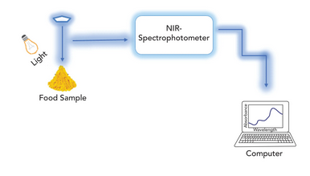
Figure 1 Schema of the Near-infrared (NIR) measuring process (Copyright © 2020 Spectroscopy Volume 35 Issue 11).

This technique is also capable of detecting components present in small concentrations. Many researchers in the food industry rely on NIR spectroscopy for measuring food adulteration because it provides safe and reliable data. [13]
In machine vision, NIR spectroscopy offers superior hyperspectral information about food stuff when juxtaposed with multispectral imaging technologies. These benefits have led to the adoption of NIR spectroscopy for mapping aflatoxin-contaminated regions of dried figs.

.

Thesis Content
The document starts by giving thanks to individuals or organizations that participated in the research or project. It then provides a brief overview of the entire document in the form of an abstract that presents major findings and issues raised in it. To ensure clarity, the list of symbols and abbreviations is given first then comes the lists of figures, equations, and tables so that they can be easily found.
The introduction gives an insight by providing background information as well as stating what the research or project will involve and its scope. It briefly explains the thesis content and mentions the research objectives. After this follows a detailed literature review which discusses relevant works within which it tries to establish context and highlight some of the areas that need more understanding.
The design section is focused on explaining the design process including real world constraints and conditions as well as cost considerations while adhering to engineering standards. Details are provided for the design like components and specifications.
The methods section includes an explanation of the techniques applied which have dataset preparation, near infrared (NIR) spectroscopy options for measurements along with training deep learning models and model construction; an additional step to discuss here are pre-processing step and then integration plus testing of models in Raspberry Pi.
Analysis of the implications of the study findings is contained within results and discussion part. This part explores various experimental trials or variations. Key findings and their importance are summarized in the conclusion.
A list of references appears after a citation style while appendices contain more content that would help you get detailed information about this topic. Each appendix is arranged in an alphabetical order to facilitate ease in locating information needed.

RESEARCH OBJECTIVE
Spectroscopic analyses generally involve instrumental measurements based on the absorption, transmission, or reflection of light by solutions. A substance's absorption of light at a specific wavelength is a characteristic property, similar to its other physical or chemical attributes [14]. A typical NIR spectroscopy unit usually comprises a light source, a light dispersal system, a sample detector, an optical detector as well as a data processing analysis system. (Figure 2)
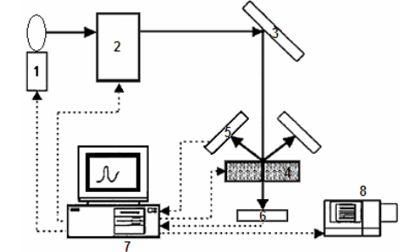
Figure 2 An NIR spectroscopy system consists of the following components: (1. Light Source; 2. Light Dispersion System; 3. Reflector; 4. Sample Holder/Detector Input; 5. Reflection Detector; 6. Transmission Detector; 7. Data Processing Analys (Copyright 2011 © from references 14).
NIR spectroscopy is a sort of technology that is applied in analyzing food stuffs to ascertain their quality attributes fast and harmlessly. It relies on 78125 angstroms to 2.5µm wavelength region of electromagnetic wave energy absorption for its analysis of food items. The correlation between the absorption of electromagnetic spectrum in the mentioned wavelength range and the quality characteristics of food samples enables NIR spectroscopy has become a standard tool for physical and chemical analyses of food and agricultural products. Data is mostly collected by looking at how much light goes through it, or off the surface, and this will vary based on what’s being measured so one needs to be flexible about the acquisition method used.
The spectral data generated by NIR is important for understanding the structure of molecules as they react to these vibrational combinations of bonds. O–H, C–H, C–O, and N–H are some of the molecular bonds that are captured by the near-infrared (NIR) region of the electromagnetic spectrum.
These bonds exhibit specific vibrational energies, which are measured using NIR frequencies. [15]. NIR Spectroscopy has found extensive application in food research because it can capture spectral bands containing vital information related to the food content. NIR spectroscopy provides even more accurate hyperspectral data for food products than what multispectral imaging can offer in machine vision. In fact, various studies have investigated NIR spectroscopy methods for food inspection recently. [16]
Efforts have been exerted on chemometric algorithms for the classification of aflatoxin-contaminated based on NIR spectroscopy. Least square support vector machine was experimented for detection, along with partial least square regression, polynomial PLS, artificial neural network, and support vector regression. In recent years, chemometrics has started the ability to benefit from convolutional neural network, one of the important network schemes developed in the current deep learning revolution. [17] et al. choose to classify vibrational spectroscopy (Raman, NIR and FT-IR) by the use of CNN and a retraining algorithm was created to identify important wavelengths while [18] et al. used CNN in the prediction of NIR data and observed the automatic pre-processing of a spectrum that can be performed by a convolutional filter [19] et al. split NIR spectra into numerous subintervals that were used as inputs in CNN models and then applied a genetic algorithm (GA) for the optimization of individual subinterval model parameters, thus leading to enhanced representativeness of features compared to fixed convolutional parameters (CPs). Considering all these recent studies, it is evident that spectroscopy greatly benefits from the inclusion of CNN, given its virtue such as strong extensive ability, requiring less beforehand knowledge for the dataset, ease of integrating spectral information, and capability of finding effective bands. As can be seen, CNN has promising results in the processing of NIR spectral data.
In the context of visual processing, deep learning refers to the use of multi-layered "deep" neural networks to extract features from a large amount of labeled training data. These methods are notable for their high classification accuracy rates. It is now well known that Convolutional Neural Networks (CNNs) represent the basic structure of deep learning. This basic structure includes convolutional layers in combination with pooling ones in the first stages. Among the key elements in the design of projects, the CNN architectural structure plays a significant role. Drawing inspiration from our own brains, deep learning methods have had a major impact on solving problems in identification and categorization of pictures. Full training on an image categorization task requires that you start off at the very beginning of designing your CNN model architecture, yet it might take some time before this is completed thus making it difficult. One way to address this would be to provide the system with pre-trained models that were developed based on larger amounts of data as compared to what was used by the system at hand considering this information, efforts have been made towards the automatic classification of dried figs without damage or spoilage.
The primary aim of this study is to enhance an accurate and reliable method for detecting aflatoxin contamination in dried figs and for determining the extent of surface mycotoxin contamination, using near-infrared (NIR) spectroscopy. This approach is designed as an alternative to traditional chemical analysis and other conventional methods. In this study, a precise and reliable approach is presented to detect aflatoxin and surface mycotoxin contamination in fig samples using NIR spectroscopy absorbance as an alternative to chemical analysis and conventional methods. There is no dataset for dried figs that are exposed to aflatoxin. A collection of figs formed the basis of a brand-new dataset for the purpose of this research. The study addresses a classification problem: the identification of aflatoxin-contaminated versus uncontaminated figs. Subsequently, each fig sample is individually labeled based on the results. Using linear and non-linear classifiers, along with convolutional neural network (CNN) algorithms, the system classifies figs contaminated with aflatoxin and mycotoxin-contamination figs.

LITERATURE REVIEW

[20] According to their study conducted in 2013, Gunes et al reported detecting aflatoxin contamination in dried figs at more than 90% accuracy by utilizing near-infrared (NIR) spectral reflectance between 780 nm and 2500 nm. It was reported that the Linear Discriminant Classifier (LDC) and Logarithmic Linear Classifier (LOGLC) methods were utilized for the task Nevertheless, the use of wavelengths in the range of 780 to 2500 nanometers permits the analysis of a great variety of constituents or characteristics; however, obtaining the entire spectrum might take too long thereby decreasing efficacy in applications. This might not be practical for real-time sorting operations.
A high classification accuracy of 97% was achieved in distinguishing between medium and heavily fungus-infected chestnuts and control samples [21].Reflectance NIRS was employed by Wu, Xie, & Xu to differentiate between infected and uninfected almonds, particularly when there were no obvious visual external differences between kernels. The use of canonical classifier resulted in total cross-validation error rate of 0.26%, in delineating infected from uninfected kernels. Most indicative factors in identifying infected almonds as well as distinguishing between A. flavus or A. parasiticus-infected ones were NIRS wavebands linked to lipid content.
Compared to conventional NIRS, FT-NIRS further enhances spectral accuracy, reproducibility, and wavelength resolution through interferometry [22]. Many researchers have studied using FT-NIRS for non-invasive mycotoxin detection in farm produce due to its higher instrumental stability that allows for static detection and not suitable for integration into industrial sorting machines because it is susceptible to mechanical vibrations and temperature changes as well as depth of light penetration and the ability to predict.
NIRS wavebands associated with lipid content were instrumental in distinguishing between almonds infected with A.flavus or A.parasiticus and healthy almonds. Externally contaminated nuts and dry fruits can be analyzed by reflectance spectroscopy while transmittance spectroscopy can provide internally specific information about contaminated samples. Transmittance NIRS was employed by [23] A distinction is sought between figs infected and those not infected with A. niger. The successful classification of infected and uninfected figs was accomplished using the most discriminative five features that were selected from 3648 spectral bands. The above bands ranged from 200 to 1100 nm.

DESIGN

Realistic Constraints and Conditions
Economy
When discussing the DLP210NIR SCAN device in terms of economics, the cost implications of the project output and its potential economic benefits should be examined.
From a cost perspective, the initial expenses related to the DLP210NIR SCAN device include the purchase price, as well as ongoing costs such as maintenance, repairs, and periodic calibration. The quality and limited longevity of the components used in this device can affect the total cost of ownership.
The DLP210NIR SCAN device is recognized for its significant economic contributions, especially when used in industries relying on near-infrared spectroscopy for quality control or material sorting. Higher client satisfaction and prospective market expansion are the result of a faster domain spectrum analysis, which in turn causes higher production effectiveness, lower garbage generation levels and enhanced item quality This can offer a competitive advantage for companies, both domestically and internationally, as they are able to deliver more reliable products at a lower cost.
Also, the employment of this technological advance may boost innovation and increase market portion in respective sectors. Given a scenario where the device enables faster and more accurate sorting in an agricultural setting, for example, higher yields are potentially achievable and there could be reduced contamination, which provides a strong economic case for it. This will raise competition in the local market and open opportunities for exportation to other nations.
Cost Analysis
Cost analysis aims to detail various expenses associated with a project, including labor, raw materials, necessary machinery and equipment, service procurement, and processing costs. In the context of the DLP210NIR SCAN device, a comprehensive cost analysis can help assess its overall impact on the project and its financial viability.
With the DLP210NIR SCAN device, improved efficiency can be achieved by enabling rapid and accurate analysis of materials. Less time needed for manual inspection or analysis implies decreased labor costs due to more efficient operations. Further, the process streamlining capabilities of the device may reduce the necessity for extra machinery or equipment hence driving down total expenses The near-infrared (NIR) spectroscopy capabilities of the DLP210NIR SCAN device allow for the detection of contaminants or impurities, leading to enhanced product quality. This improved quality control can reduce the need for rework or recalls, resulting in cost savings in terms of raw materials and labor.
One of the disadvantages of the DLP210NIR SCAN device is the high initial investment cost. The purchase of the device and related equipment, as well as the necessary training for operators, is costly. Regular maintenance and calibration are required to ensure the accuracy and reliability of the device. These ongoing costs can contribute to the project's budget and potentially affect its overall cost-effectiveness.

Sustainability
The materials employed in product design should be able to withstand the test of time, not become waste after their use and be recycled into the same or other objects if they can be - this is what sustainability is all about The DLP210NIR SCAN device plays a significant role in supporting sustainability across various industries.
The DLP210NIR SCAN device employs near-infrared (NIR) spectroscopy to rapidly analyze material composition. This rapid analysis is crucial for evaluating the sustainability of materials used in product design, allowing for the identification of recyclable components and the detection of potentially harmful substances. This capability is valuable for industries aiming to create environmentally friendly and easily recyclable products. The DLP210NIR SCAN device can be used in sorting and recycling facilities to quickly and accurately separate different types of materials. This capability is essential for efficient recycling processes, reducing the amount of waste sent to landfills, and supporting sustainable waste management practices.
One possible drawback of the DLP210NIR SCAN device is its initial cost. The equipment and training required for proper operation can be expensive, potentially presenting a barrier for small-scale businesses or organizations with limited budgets. This cost factor could hinder the broader adoption of the technology in certain industries.

Cost of the Design
When detailing the design cost of the DLP210NIR SCAN NANO device, it is crucial to analyze the various components and their associated costs. In an academic context, the subsequent paragraph is an example of how one can present a breakdown of costs.

Core Components
NIR Spectrometer: The DLP210NIR SCAN NANO device's primary component. The cost for a high-quality near-infrared spectrometer changes according to its model and specifications, commonly ranging between $800 and $1,200.
Optical Components: This includes lenses, mirrors, and prisms used in the spectrometer. The estimated cost for these components is between $200 and $600.
Detector Array: This is used to capture the NIR signals. The cost of a quality detector array typically ranges from $800 to $900.

Supporting Hardware
Electronic Circuitry: This encompasses microcontrollers, amplifiers, and other electronic components. The estimated cost for the circuitry is between $200 and $500.
Enclosure: The casing or housing for the device. The price of a robust enclosure typically ranges from $100 to $500.
Mounting Hardware: Screws, brackets, and other fixtures. This usually costs between $50 and $200.

Software and Calibration
Software Development: Custom software may be required for the device's operation and data analysis. The cost for software development can vary, typically between $700 and $850.
Calibration Tools: Calibration standards and tools are needed to maintain accuracy. The cost for these tools is estimated to be between $200 and $800.

Labor and Services
Testing and Quality Assurance: The costs associated with testing the device and ensuring quality. This can range from $500 to $1,000.
Service Contracts: Ongoing maintenance and support services. The cost for service contracts usually ranges from $500 to $1,000 annually.
his detailed cost analysis provides a comprehensive view of the expenses associated with designing and building the DLP210NIR SCAN NANO device. The book can be used as a financial planning and project budgeting handbook.

Engineering Standards
IEEE 10.23919/EUSIPCO.2017.8081633: This standard focuses on the utilization of Raspberry Pi for image processing education. It provides guidelines and best practices for the use of Raspberry Pi platforms in educational contexts. In the design of the DLP210NIR device, this standard was referenced to ensure the alignment of the device's image processing capabilities with educational objectives and to render it suitable for academic environments.
IEEE 10.1109/UBMK.2017.8093521: This standard pertains to data classification using deep learning with TensorFlow. Information is provided regarding the implementation of deep learning algorithms for data classification tasks. In the context of the DLP210NIR device, this standard guided the integration of TensorFlow-based deep learning models for image classification, enabling the device to accurately classify data obtained through NIR spectroscopy.
IEEE 10.1109/ICECENG.2011.6057428: This standard focuses on the use of the Python programming language for data processing. It outlines best practices for coding in Python to ensure efficient and effective data processing workflows. Adherence to this standard in the design of the DLP210NIR device ensured that the data processing algorithms implemented on the device were well-structured, modular, and optimized for performance.

Details of the Design
The designed system and each step implemented are presented below (Figure 3).

Figure 3 A flow chart for the designed system.

- Data Collection: After the chemical process, the figs obtained started to be collected data by the NIR device.

- Convert .csv Spectral Files İnto .png Files Via MATLAB: The collected data was converted from .csv to .png format via MATLAB.

- Training Code Procedure: At this stage, the code writing process was initiated.

- Load Required Libraries: Required Python libraries are loaded.

- Define Constants: Constants are defined, such as BATCH_SIZE and IMAGE_SIZE.

- Load Image Dataset: The dataset is loaded; it contains images and their labels.

- Split Dataset into Train, Val, Test: The data set is divided into three parts: training data, validation data and testing data.

- Shuffle: The dataset is optionally shuffled.

- Normalize and Resize: Images are normalized (scaled between 0 and 1) and resized.

- Cache and Prefetch: The dataset is cached and prefetched, speeding up the training process.

- Define Neural Network Model: The neural network model is defined; it consists of input, hidden, and output layers.

- Compile and Train the Model: The model is compiled and trained; a specified loss function and optimization algorithm are used.

- Evaluate Model: The model's performance is evaluated; accuracy and loss metrics are calculated.

- End: The end of the workflow is represented; it's where the program terminates.

- Save the Trained Model h5 file: The parameters after training have been saved as an h5 file.

- Testing the model with unseen Test Dataset via Raspberry Pi: A h5 file will be saved and label prediction will be made with previously untrained test images.

- Load Required Libraries: Required Python libraries are loaded.

- Load Test Image Dataset: The test dataset is loaded.

- Import Test Datasets and Define Labels: Loads image data and defines their labels.

- Shuffle: The dataset is optionally shuffled.

- Import The Trained Model: The model saved as h5 was imported.

- Evaluate The Model: The trained model was evaluated with images it had not seen before. The model was tested and evaluated with unseen images at this point.

- Calculate Accuracy Rate and Loss: The accuracy rate and loss values were calculated.

METHODS
In the beginning, Spectroscopy is a technique that allows the identification of samples by utilizing their absorption or emission properties across different light wavelengths. The DLP NIR scan Nano EVM is an evaluation module that simplifies the design of portable near-infrared spectrometers (Figure 4). Industries like food, pharmaceuticals, oil & gas, medicine, security amongst others are being provided with top-drawer spectroscopy from laboratories because of this technology.
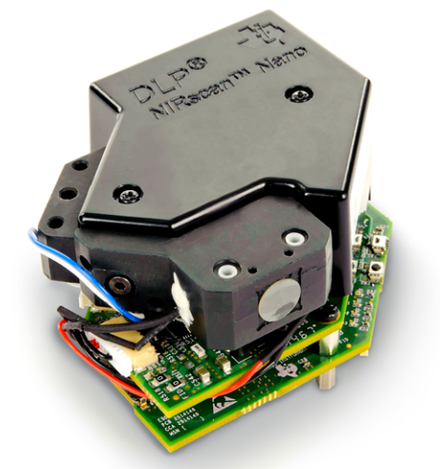
Figure 4 DLP NIR scan Nano Evaluation Module (Copyright 2017 © from Texas Instruments, EVM User’s Guide).
The project aims to autonomously classify healthy and aflatoxin-contaminated figs using the Python programming language, Single Board Computer (Raspberry Pi), and machine learning methods. Data collection has been facilitated by the resources provided by the university.
The method was proposed to have three major steps:
- Preparation of the Dataset: Monitoring of chemical processes and performing necessary measurements to create the datasets.
- Training of Deep Learning Models: Training deep learning models for the classification task.
- Integration and Testing on Raspberry Pi: Integrating the developed system into the Raspberry Pi, followed by testing and validation.
By following these steps, the goal is to achieve autonomous classification of healthy and aflatoxin-contaminated figs.

5.1. Preparation of the Dataset
A total of 1.5 kg of fig samples (0.5 kg contaminated with aflatoxin and 1 kg healthy) were provided by the Supervisor, İpek Baz, for experimental studies. Experts classified the fig samples using UV light fluorescence properties into two groups: aflatoxin-contaminated and uncontaminated ones.
A total of 14 aflatoxin-contaminated figs and 25 healthy figs will be measured. Since the number of aflatoxin-contaminated figs is low, each fig will be measured with its two sides. From each side, 50 spectral data points were collected from different points (Figure 5)Due to the higher number of healthy figs, a total of 700 spectral data points were collected from healthy figs by sampling 28 spectral data points from both sides and different locations. (Figure 6, Figure 7). A total of 1400 data are available, with 700 representing aflatoxin-infected figs and 700 healthy ones.
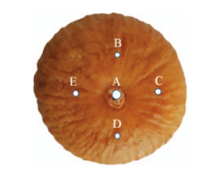
Figure 5 The fig samples have different regions from which data are received (Copyright 2018 © from Ahmet Seçkin Bilgi 05/29).

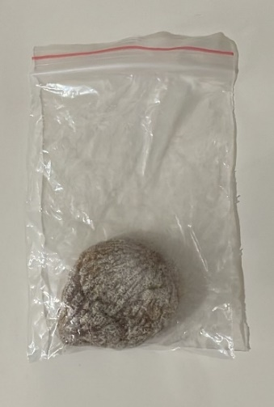
Figure 6 Healthy fig example.
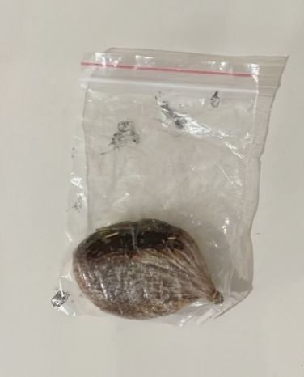
Figure 7 Fig example with aflatoxin.

Options for NIR
Various parameters of NIR scanning Nano, such as resolutions 228 and 352, and scanning numbers 20 and 40, were tested, and measurements were taken. It was observed that the The best outcome was realized with 20 epochs and a resolution of 228. Therefore, measurements were taken with settings of 20 epochs and 228 resolutions. As seen in the graphs below (Figure 8, Figure 9), the absorbance values of 500 aflatoxin-contaminated and 500 healthy dried figs are displayed.
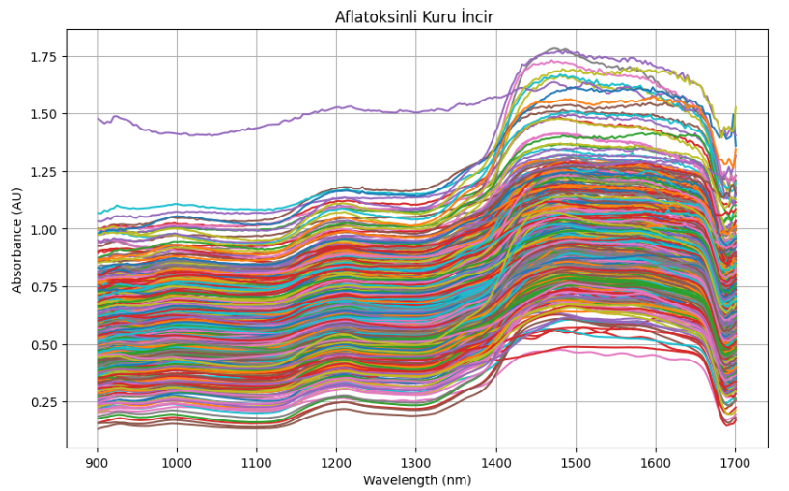
Figure 8 Absorbance values of dried figs with aflatoxin.
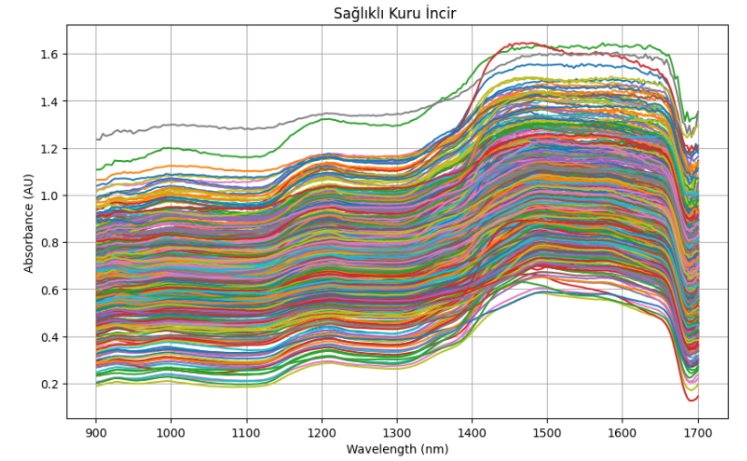
Figure 9 Absorbance values of healthy dried figs.

Trials were conducted with white and black backgrounds while measuring with the NIR device, but the presence of reflected light or light entering the room during measurement hindered obtaining accurate results. Therefore, the unsuitability of the measurement environments was also a problem. To address this issue, a custom box design was used. (Figure 10, Figure 11,).
The data will be collected using an NIR device to capture spectral information. This will allow the analysis of the effects of aflatoxin on healthy and contaminated figs at different wavelengths. NIR devices have the capability to capture images beyond the visible spectrum.
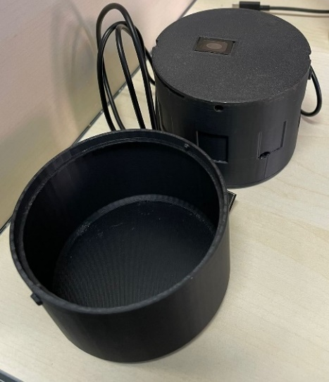
Figure 10 Custom Box Design

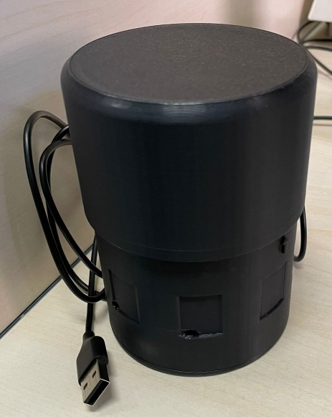
Figure 11 Custom Box Design

Spectroscopic Measurements
After each measurement, the obtained spectral data was properly saved (Figure 12,Figure 13,). These data represent the intensity and distribution of different chemical components of the samples according to wavelengths. The spectrometer wavelength range of the used DLP NIR scan nano measurement device is between 900-1800 nm. After comprehensive review of the literature and experiments, it was determined that spectral data were recorded in three different formats: absorbance, reflection, and intensity. Subsequently, it was revealed that the most effective classification for dried figs was achieved using absorbance values. Absorbance, a critical measurement in the classification of dried figs, holds significance due to its ability to reflect the amount of light absorbed at specific wavelengths. Additionally, utilizing absorbance values may facilitate clear differentiation among various classes of dried figs, thus ensuring accurate product classification. Therefore, absorbance emerges as a significant metric in the classification of dried figs. Subsequently, for each fig, data were collected based on the reflection value of light from different points over 20 epochs, spanning from 900 nm to 1800 nm, resulting in healthy and aflatoxin-contaminated fig data each carrying 1400 absorbance values.

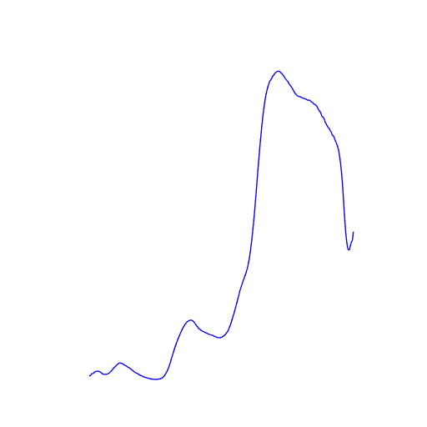
Figure 12 Dried figs with Aflatoxin Absorbance graph.
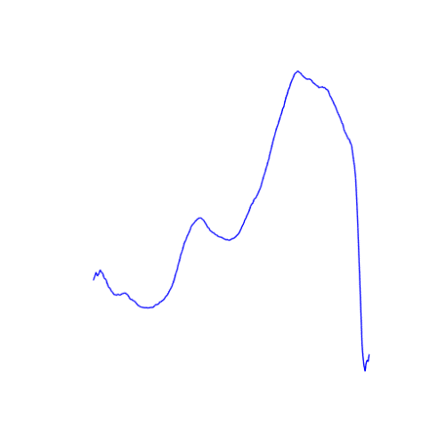
Figure 13 Healthy fig absorbance graph.

5.3. Training of Deep Learning Models
Using an NIR device, spectral data were collected from healthy and contaminated figs. These spectral data reflect the absorbance values of light at different wavelengths. The spectral data collected with the NIR device were processed to convert them into .png images through appropriate procedures. Each image represents the absorbance of light at different wavelengths. Preprocessing steps were applied such as normalize and resize to the obtained .png images. These steps include data augmentation.

5.3.1. Pre-processing
One must resize images to desired dimensions before providing them to the network. Besides, image pixel values should be normalized for better model performance; this involves dividing by 256 so that all values lie between zero and one.

5.3.2. Model Architecture
In training, 500 aflatoxin-infected and 500 healthy figs were utilized, totaling 1000 data points across two classes. Among these, 80% were allocated for training, 10% for validation, and the remaining 10% for testing (Figure 14). The model's parameters, layers, hyperparameters, optimizer were optimized to their best configurations. The results became more reliable after the data had been improved. Finally, deep learning models' training took place using those images after all required pre-processing phases had been completed.
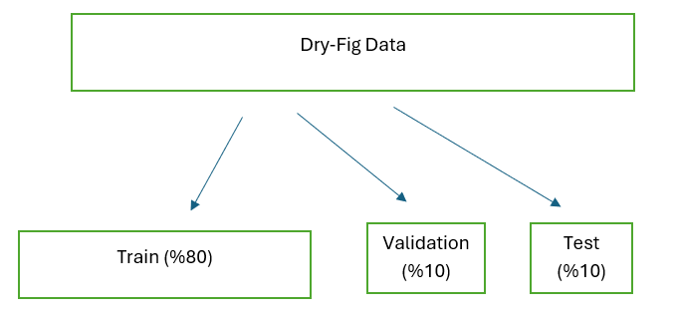
Figure 14 Splitting the Data.

It has been decided that there should be a batch size of 64 as well as an image size of 512 given that it is a hyperparameter. Batch size is a variable which determines how many instances are processed at a go in order to train this model with train, validation and test data. (Figure 15).
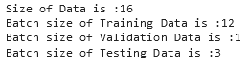
Figure 15 Batch Sizes

The learning rate hyperparameter has been set to 0.0001. Changing these values will demonstrate that higher learning rates accelerate the model's training process. Nonetheless, extremely high speeds might destabilize training. On the other hand, reducing it to rates too low might compromise its quick learning abilities. Additionally, the ReduceLRPlateau technique is employed to dynamically adjust the learning rate during training. In case the model starts showing poor performance after a specific period of time during training, the learning rate is decreased automatically. The main reason behind this action is to make sure that the model is well trained at all times thus producing desirable results.
As a Convolutional or deep learning model's primary layer Input Layer is responsible for bringing the information supplied to the network to its active dimensions. During training images need to be resized for predetermined deep learning algorithms. Kernels refer to $mxn$-sized K filters circulated over the two-dimensional $ixj$ $I$ -sized image (input matrix) [24].
These filters can also be used by the user when they use some filters available in the literature. In the Convolution Layer, a new convolution matrix ($S_{i},j$) is created by circulating the K kernels on the $I$ matrix from the input layer. A detailed breakdown of the operation carried out in the convolution layer is illustrated in Equation 1.
$$S_{i,j}=(I*K)_{i,j}=\sum_{m}{\sum_{n}{I_{i,j}K_{i-m,j-n}}}$$
Equation 1 Convolution Layer
Activation Layer is the layer used to reduce the value (𝑥 = $S_{i},j$) obtained from the convolution layer to certain intervals. In the literature, Rectified Linear Unit (ReLU) is used (Equation 2).
$$f\left(x\right)=\max\left(0,x\right)=\left\{\begin{aligned}0 if x<0 \\ x if x≥0\end{aligned}\right.$$
Equation 2 ReLU Activation Function

When data from the activation layer is attempted to be made significantly smaller, the Pooling Layer is employed, a 2x2 matrix is circulated on the data coming from the Activation layer ($A_{i,j}=f_{(X_{i,j})})$ as shown in Figure 16. Sometimes this filter function works by skipping some. This skipping process is called “stride”. As a result, while data reduction takes place in Pooling layer that makes the network to be swifter, however, it can result in some data losses.

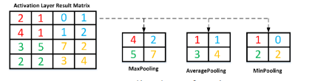
Figure 16 Pooling layer functions (Copyright 2021 © from Sedat Metlek, Vocational School of Technical Sciences).
Output Layer may be formed from Flatten Layer, Full Connected Layer and Classification Layer at its core. The Flatten Layer converts data from prior layers into vectors in $nxm$ dimensions. The data converted to vector is multiplied by the relevant weight values in the full link layer and the bias value is added. The values obtained after this stage are sent to a classifier depending on the initiative of the user. In the literature, the SoftMax classifier given in Equation 3 is generally used in this layer [24].
$$S\left(Y_{i}\right)=\frac{e^{y_{i}}}{\sum_{j=1}^{n}{e^{y_{j}}}}$$
Equation 3 The SoftMax Classifier.

In Equation 3 $e^{y_{i}}$ denotes, model output speaks of probability, and $\sum_{j=1}^{n}{e^{y_{j}}}$1 represents the probability sum of all output values of the model.
As can be seen in the following figure in Figure 17, dropout is implemented in the layer. safeguarding against Dropout involves randomly switching off reasons by zero moments neurons of a particular group on them when the machine is learning process benefit for model overfitting avoidance and improvement in extent of generalization. Like dropout, kernel regularization is a technique employed to control model complexity, preventing overfitting, and enhancing the model's generalization performance. The L2 regularizer specifically utilizes the sum of the squares of the kernel function as a penalty (this sum is added as a penalty to the model's error function). This approach tends to produce smooth solutions, where all parameters exhibit values close to zero.

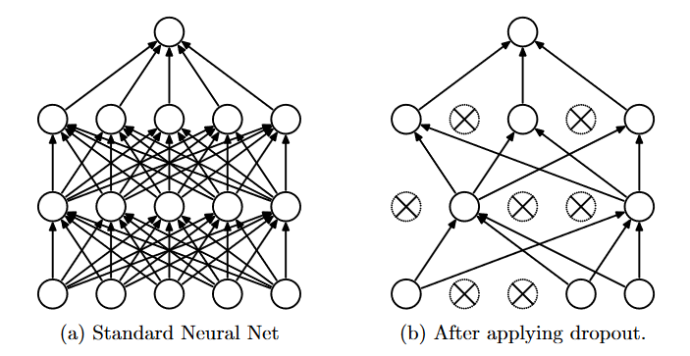
Figure 17 Dropout Layer (Copyright 2016 © from Budhiraja Amar, Dropout in (Deep) Machine learning).
The optimization of the loss function by updating weights of an artificial neural network is based on a learning algorithm, after certain parameters have been identified. It is chosen as the Adam optimizer, which is faster, efficient in addition to being insensitive to noise due to its robustness as well as insensitivity to hyperparameter setting. Additionally, they make use of SparseCategoricalCrossentropy function in determining the discrepancy between model predictions and what really occurred. This is done to guarantee similarity of all forecasts with factual data toward minimization of any discrepancies through its designated objective function called loss function. This guides modifications during training to steer improvements towards better forecasting.
Subsequent to the completion of all aforementioned stages, the model's training commences and is brought to completion. Accuracy and loss values are meticulously measured, yielding validation loss, validation accuracy, accuracy, and loss graphs.

5.4. Integration and Testing on Raspberry Pi
Raspberry Pi is a minicomputer produced by the Raspberry Foundation. Not only is Raspberry Pi a mini-computer, but it also serves well as a basic micro-controller which senses that physical world The trained models, the saved H5 model, will be deployed and run on the Raspberry Pi to autonomously classify healthy and aflatoxin-contaminated dried figs, thereby generating results. The goal is to connect the saved and trained model, along with all its parameters, to the Raspberry Pi, allowing it to execute and produce outcomes.

RESULTS AND DISCUSSION
A model based on CNN was built from the beginning (scratch). Its quality has been enhanced by incorporating various parameters, hyperparameters, optimizers, and layers.

Different Trials
Attempt-1
The model was trained with a batch size of 32 and images of size 512. The dataset was split into 80% training, 10% testing, and 10% validation sets. Regularization was applied, with a learning rate set to 0.0001, and early stopping was implemented. The results obtained with these settings are presented below (Figure 18,Figure 19). The post-training accuracy rate was %0.9271, with a loss value of %0.2518. The test accuracy rate was %80.75, and the loss value was %0.42.
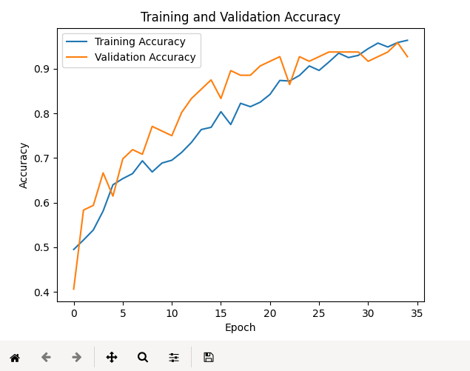
Figure 18 Training and Validation Accuracy Graph
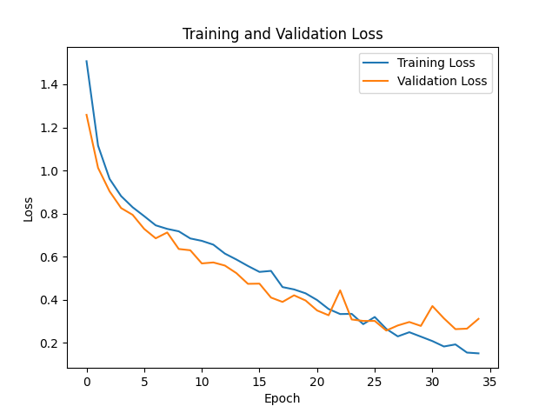
Figure 19 Training and Validation Loss Graph

Attempt-2
The model has been trained with a batch size of 32 and images of size 512. The dataset was split into 70% training, 20% testing, and 10% validation sets. Regularization was applied, with a learning rate set to 0.0001, and early stopping was implemented. The results obtained with these settings are presented below (Figure 20,Figure 21). The post-training accuracy rate was %0.9479, with a loss value of %0.1807. The test accuracy rate was %85, and the loss value was %0.37.
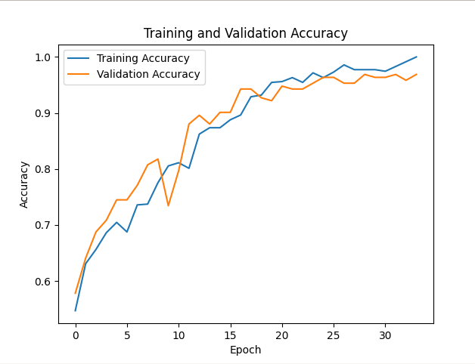

Figure 20 Training and Validation Accuracy Graph
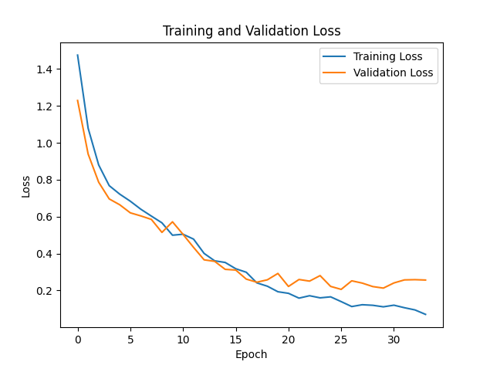
Figure 21 Training and Validation Loss Graph

Attempt-3
The model has been trained with a batch size of 32 and images of size 512. The dataset was divided into 70% for training, 20% for testing, and 10% for validation. Regularization was applied by setting the learning rate to 0.00001, and early stopping was implemented. Finally, ReduceLROnPlateau was utilized. The results obtained with these settings are presented below (Figure 22,Figure 23). The same settings were applied, but only the learning rate was reduced to 0.001, resulting in significantly lower accuracy and higher loss. The post-training accuracy rate was %0.9323, with a loss value of %0.2362. The test accuracy rate was %79, and the loss value was %0.50.
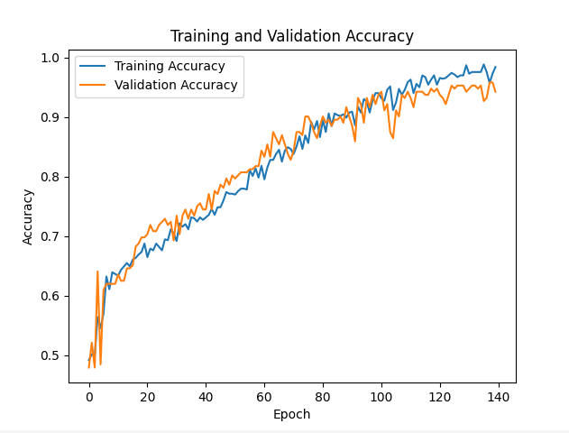
Figure 22 Training and Validation Accuracy Graph
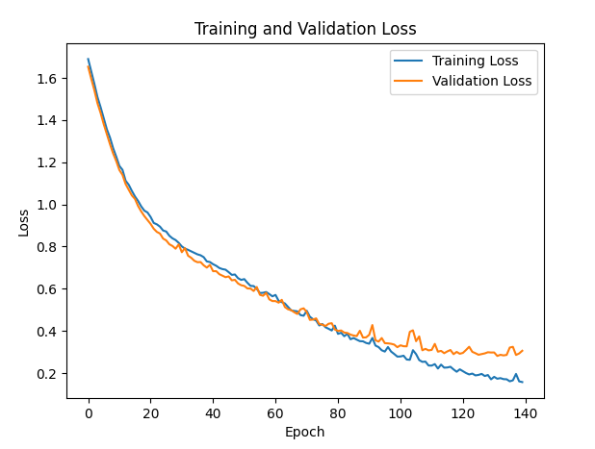
Figure 23 Training and Validation Loss Graph
Attempt-4
The model has been trained with a batch size of 64 and images of size 512. The dataset was segmented into 80% for training, 10% for testing, and 10% for validation. Regularization was applied by setting the learning rate to 0.0001, and early stopping was implemented. The results obtained with these settings are presented below (Figure 24,Figure 25). The post-training accuracy rate was %0.9870, with a loss value of %0.1169. The test accuracy rate was %84, and the loss value was %0.53.
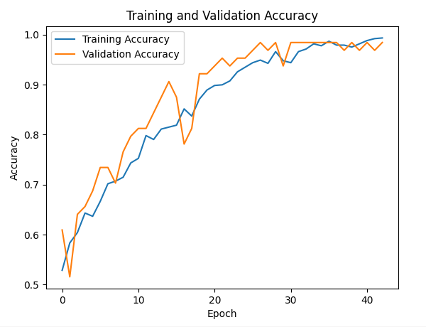
Figure 24 Training and Validation Accuracy Graph
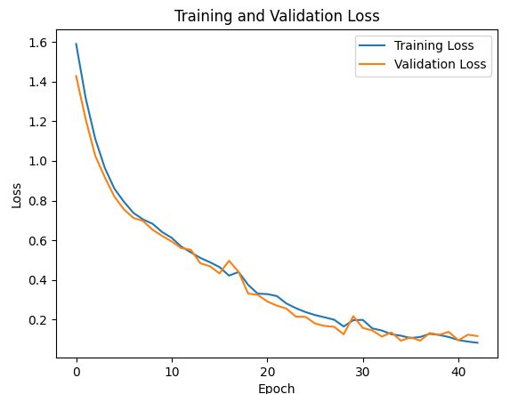
Figure 25 Training and Validation Loss Graph

Attempt-5
The model was trained with a batch size of 32 and images of size 512. The dataset was segmented into 80% for training, 10% for testing, and 10% for validation. Regularization was applied by setting the learning rate to 0.0001, and early stopping was implemented. The results obtained with these settings are presented below (Figure 26,Figure 27). The post-training accuracy rate was %0.9865, with a loss value of %0.1151. The test accuracy rate was %85.55, and the loss value was %0.35.

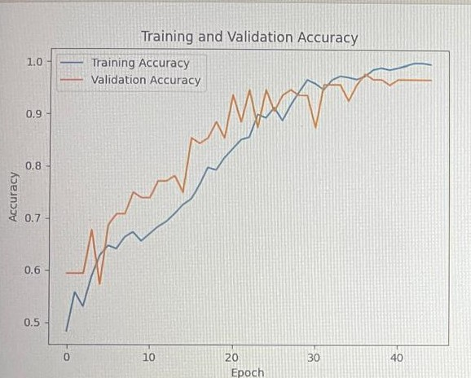
Figure 26 Training and Validation Accuracy Graph
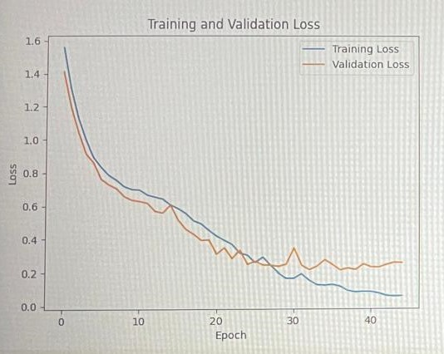
Figure 27 Training and Validation Loss Graph

Attempt-6
The model was trained with a batch size of 32 and 512-dimensional images. Data augmentation was applied (brightness and contrast adjustments). The dataset was segmented into 70% for training, 20% for testing, and 10% for validation. Regularization was applied with a learning rate set to 0.00001, and early stopping was implemented. Finally, ReduceLROnPlateau was utilized. The results obtained with these settings are presented below. (Figure 28,Figure 29). The post-training accuracy rate was %0.9219, with a loss value of %0.2913. The test accuracy rate was %79.75, and the loss value was %0.40.
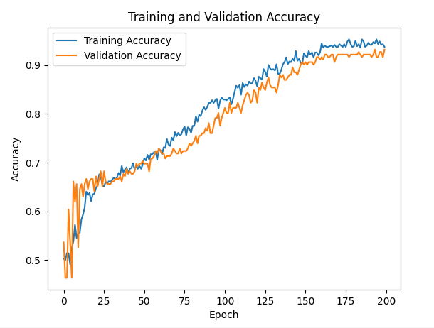
Figure 28 Training and Validation Accuracy Graph

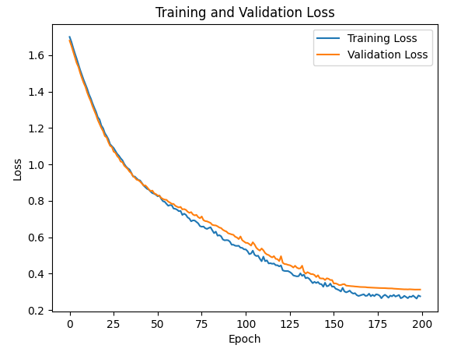
Figure 29 Training and Validation Loss Graph

Attempt-7
The model was trained with a batch size of 64 and 512-dimensional images. Data augmentation was applied (brightness). The dataset was segmented into 80% for training, 10% for testing, and 10% for validation. Regularization was applied with a learning rate set to 0.0001, and early stopping was implemented. The results obtained with these settings are presented below (Figure 30,Figure 31). The post-training accuracy rate was %0.9740, with a loss value of %0.1248. The test accuracy rate was %81.75, and the loss value was %0.53.
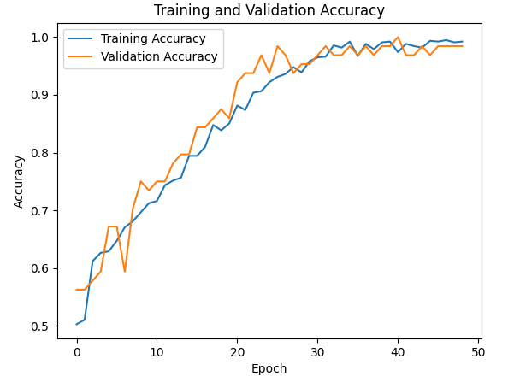
Figure 30 Training and Validation Accuracy Graph

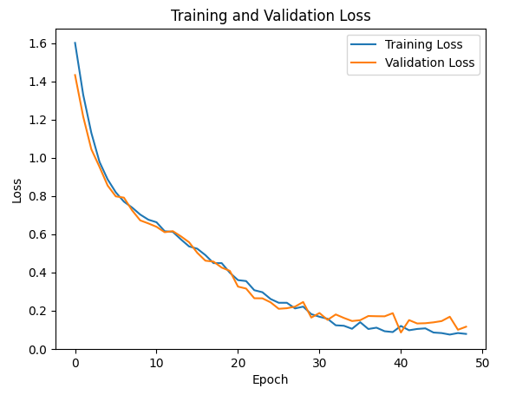
Figure 31 Training and Validation Loss Graph

Attempt-8
The model was trained with a batch size of 64 and 512-dimensional images. Data augmentation was applied (brightness). The dataset was segmented into 80% for training, 10% for testing, and 10% for validation. Regularization was applied with a learning rate set to 0.00001, and early stopping was implemented. The results obtained with these settings are presented below (Figure 32,Figure 33). The post-training accuracy rate was %0.9779, with a loss value of %0.2005. The test accuracy rate was %82, and the loss value was %0.48.
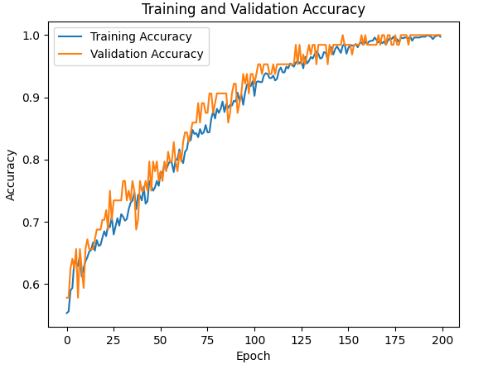
Figure 32 Training and Validation Accuracy Graph
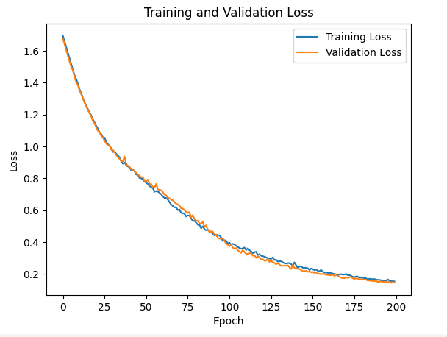
Figure 33 Training and Validation Loss Graph

Attempt-9
The previous model was saved, and normalization was applied to the aflatoxin class included in the test code, while it was not applied to the healthy class. The test accuracy rate was %92.75, and the loss value was %0.37.
Attempt-10
Normalization was not applied to the aflatoxin class included in the test code, whereas it was applied to the healthy class. The test accuracy rate was %39.75, and the loss value was %0.89.
Attempt-11
Normalization was applied to both the aflatoxin class and the healthy class included in the test code. The test accuracy rate was %50, and the loss value was %0.78.

As observed in the above figure, the loss consistently decreases with each epoch, while accuracy consistently increases. Validation accuracy exhibits an upward trend, with minimal fluctuations or occasional slight decreases in certain epochs. Attempt-8 was selected for being appropriate due to continuous, regular, and smooth decreasing in validation loss.
The one that was chosen, which is attempt-8 to have the highest performance was able to reach training set precision of %97.79, with loss amounting to %0.2005 (Figure 34,Figure 35).
Figure 34 Training and Validation Accuracy Graph
Figure 35 Training and Validation Loss Graph

The model was tested in the colab environment with 400 data points that it had never seen before, saved as h5, accuracy rate was determined to be 82%, with a loss value of 0.48%.

All attempts made are shown in the table below (Table 3).

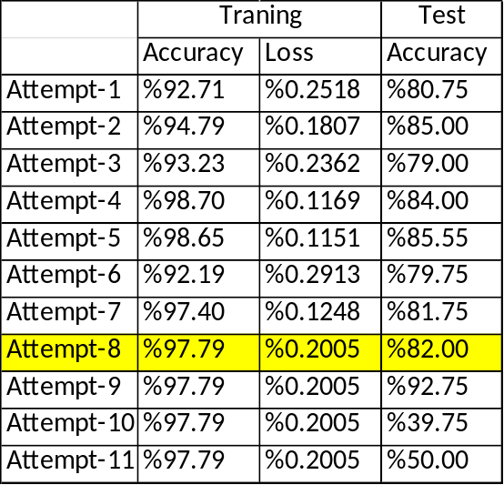

Table 3 Result of All Attempts

Furthermore, the saved h5 file was embedded in a Raspberry Pi and subjected to testing, yielding the following results (Figure 36).
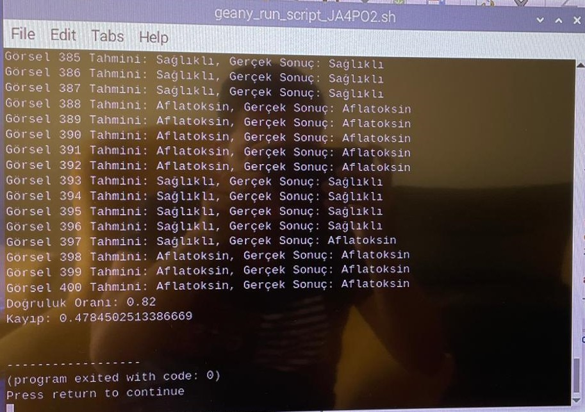
Figure 36 Result of Raspberry Pi
Additionally, the saved model was queried for both actual and predicted labels, yielding the following results (Figure 37).
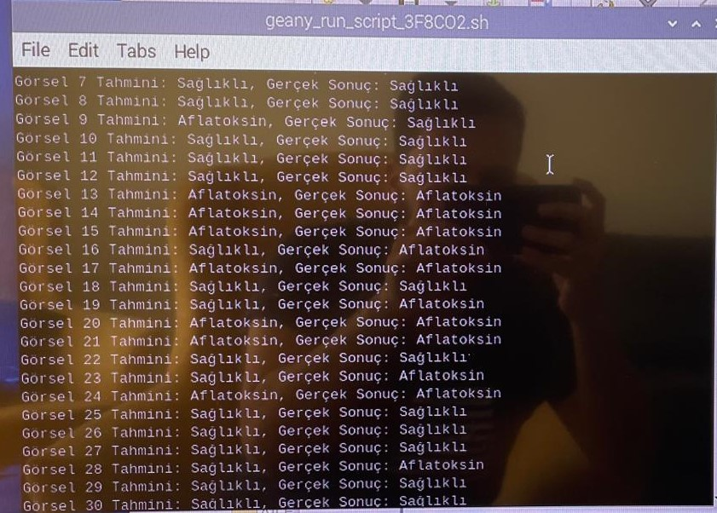
Figure 37 Prediction of Raspberry Pi

Upon examination of the graphs obtained following training, both accuracy and validation accuracy exhibit a general upward trend. However, as evident from the graph, there is a slight spikiness. This could be attributed to suboptimal conditions during the measurements and inadequacies of the enclosure designed for the measuring device.
The loss and validation loss graphs demonstrate a synchronous decrease, indicating the effectiveness of the model and training process. The absence of spikiness in accuracy and validation accuracy can be ascribed to the judicious selection of optimizers, parameters, hyperparameters, and regularizers.
When testing the saved model as h5, a slightly higher loss is observed. However, this is a common outcome for test data that the model has never encountered before. The accuracy value of 82% serves as a testament to the model's success.
In conclusion, the achieved accuracy and loss rates shed light on the project's success and provide guidance for future researchers in this field.

CONCLUSION
In the introduction, the significance of aflatoxins among other mycotoxins due to their high toxicity is emphasized. Most employed methods for mycotoxin analysis, such as LC or HPLC coupled with FL, UV, or MS, have been examined. However, it has been determined that these methods are not easily performed due to their high cost, radiation, and challenging steps. The recent years have seen the development of spectral imaging techniques aimed screening agricultural and food products. Near-infrared (NIR) spectroscopy is rapidly turning into a common, quick technique applied to identify infections with mycotoxins found in food products. The NIR spectroscopy technique has been chosen to identify aflatoxin-contaminated areas in dried figs.
In the research objective section, the focus has been on developing an accurate method to detect aflatoxin contamination in dried figs and evaluating surface mycotoxin contamination using near-infrared (NIR) spectroscopy is a substitute for traditional methods. The NIR device assists in determining material properties by analyzing NIR spectra. Deep learning, especially CNNs, is used to take out features from marked training data and improve classification precision. The study aims to autonomously adapt NIR device methods for the non-destructive examination of food substances. One of our primary goals is to accurately detect aflatoxins and then classify them into two categories, healthy or aflatoxin contaminated, using CNN algorithms. This approach provides a precise and reliable alternative to chemical analysis for mycotoxin detection in figs.
In the literature review section, although [3] et al. demonstrated effectiveness in achieving high accuracy, the time-consuming nature of obtaining a full spectrum in the wide wavelength range of 780 nm to 2500 nm may pose challenges for real-time applications. This issue could potentially limit the applicability of classification processes requiring instant results. Hence, there is a need for methods that balance accuracy with efficiency to ensure detection of aflatoxin contamination in dried figs in good time. The project aims precisely to fill this gap left by [3] et al., intending to establish a system that improves upon and renders feasible the situation they fell short of.

The DLP210NIR SCAN device offers significant economic and sustainability advantages.
In economic terms, it increases production efficiency resulting in reduced waste and improved quality of products that leads to higher customer satisfaction and potential market growth Its rapid analysis capabilities contribute to enhanced competitiveness and innovation in industries relying on near-infrared spectroscopy. Additionally, the device enables cost savings through reduced labor costs, minimized rework, and improved quality control.
From a sustainability perspective, the DLP210NIR SCAN device supports environmentally friendly practices by facilitating the identification of recyclable materials and detection of harmful substances. Environmentally responsible industries find it to be a useful investment because its benefits both economically as well as environmentally outstrip its demerits even though it involves high initial costs. It helps in effective recycling processes while at the same time reducing waste taken to dumpsites thereby promoting sustainable waste management practices.
In the Details of the Design section, the functioning of the general system and the steps to be applied are explained.
The proposed method consists of three main steps: data preparation, training of deep learning models, and integration and testing on a Raspberry Pi. A total of 1.5 kg of fig samples (0.5 kg aflatoxin-contaminated and 1 kg healthy) were provided by advisor İpek Baz. Spectral data points were collected from both sides of each type of fig, with a total of 700 spectral data points collected from healthy figs, resulting in a total of 1400 data points. The best results were obtained with 20 epochs and a resolution of 228. Measurements were conducted in special boxes due to issues with reflective light and ambient light. The spectral data were converted into .png images, which were then normalized and resized. Model training was conducted using 500 aflatoxin-contaminated and 500 healthy figs. The model's hyperparameters were optimized, with a learning rate set at 0.0001, using the ReduceLRPlateau method. Training was performed over 300 epochs with early stopping applied. Convolution, Activation (ReLU), Pooling, Flatten, Fully Connected, and SoftMax layers were used. Dropout and kernel regularization techniques were also applied. The Adam optimizer and SparseCategoricalCrossentropy loss function were utilized. The trained models were deployed onto a Raspberry Pi to autonomously classify the figs. After training, accuracy and loss values were measured to obtain the results. This study aims to provide an innovative approach to automatically classify healthy and contaminated products in the agricultural sector, aiming to enhance product quality and reduce human intervention.
The Results section indicates that with each epoch, the losses consistently decrease, while the accuracy rates steadily increase. Validation loss generally exhibits a decreasing trend, with occasional minimal fluctuations or rare instances of slight increases. Validation accuracy typically shows an increasing trend, with occasional minimal fluctuations or rare instances of slight decreases.
In conclusion, upon testing the model, it was determined that the accuracy rate was 97.79%, with a loss of %0.2005. However, it was observed that although the accuracy was high, the loss was slightly higher than desired. This may be attributed to the less-than-ideal environment during measurements and the inadequacy of the box designed for the measurement device, resulting in slightly elevated loss. This study has shown that it is possible to make a system which can quickly, accurately as well as dependably classify normal and aflatoxin contaminated figs.

References

[1] | P. Kumar, D. Mahato, M. Kamle and S. Kang, “Aflatoxins: A Global Concern for Food Safety, Human Health and Their Management,” Front Microbiol, 2016.
[2] | S. Senturk and H. Karaca , “Obtaining an aflatoxin-free and high-alcohol-content product using contaminated dried figs,” Mycotoxin Res., pp. 127-134, 2023.
[3] | A. Güneş, E. Durmuş and H. Kalkan, Detection of high aflatoxin risk figs with computer vision, p. 1, 2013.
[4] | F. Olaniran, A. Mokoena and J. Occurrence, “Toxicity Production and Detection of Fusarium Mycotoxin: A Review. Food Production,” Processing and Nutrition, p. 1, 2019.
[5] | H. Imge and O. Basegmez, “Dietary Exposure Assessment of Aflatoxin From Dried in Turkey,” Hittite Journal of Science and Engineering, pp. 173-177, 2019.
[6] | H. Zhou, S. George, C. Hay and X. Sun, “Individual and combined effects of Aflatoxin B1, Deoxynivalenol and Zearalenone on HepG2 and RAW 264.7 cell lines,” Food Chem. Toxicol., pp. 18-27, 2017.
[7] | Z. Richard and J. Binder, “A Review of Rapid Methods for the Analysis of Mycotoxins,” Mycopathologia , p. 261–273, 2006.
[8] | S. Kolosova, Y. Kim, J. Yang and S. Eremin, “Fluorescence Polarization Immunoassay Based on a Monoclonal Antibody for the Detection of Ochratoxin,” International Journal of Food Science & Technology , p. 829–837, 2004.
[9] | V. Fernandes , J. Fernandes and S. Cunha, Trends Food Sci. Technol. 36(2), pp. 96-136, 2014.
[10] | I. Orina, P. Williams and M. Manley, Food Res. Int. 100, pp. 74-86, 2017.
[11] | X. He, C. Yan, X. Jiang and J. You, “Classification of aflatoxin B1 naturally contaminated peanut using visible and near-infrared hyperspectral imaging by integrating spectral and texture features,” Infrared Physics & Technology 114, 2021.
[12] | Y. Wang, C. Zhang, J. Wang and D. Knopp, “Recent Progress in Rapid Determination of Mycotoxins Based on Emerging Biorecognition Molecules: A Review,” Toxins 2022, 14, 73, p. 1, 2022.
[13] | M. Paradkar, S. Sivakesava and J. Irudayaraj, Sci. Food Agric. 82(5), p. 497–504 , 2002.
[14] | M. F. Ertugay and M. Başlar, “GIDALARIN KALİTE ÖZELLİKLERİNİN BELİRLENMESİNDE YAKIN KIZILÖTESİ (NIR) SPEKTROSKOPİSİ,” GIDA (2011) 36 (1):, pp. 50-52, 2010.
[15] | H. Cen and Y. He, Trends Food Sci. Technol. 18(2), p. 72–83, 2007.
[16] | T. Pearson, D. Wicklow and E. Maghirang, “Detecting Aflatoxin in Single Corn Kernels by Using Transmittance and Reflectance Spectroscopy,” Transactions of the ASAE, 2001.
[17] | J. Acquarelli, T. v. Laarhoven and J. Gerretzen, “Convolutional neural networks for vibrational spectroscopic data analysis,” Analytica Chimica Acta Volume 954, pp. 22-31, 2017.
[18] | C. Cui and T. Fearn, “Modern practical convolutional neural networks for multivariate regression: Applications to NIR calibration,” Chemometrics and Intelligent Laboratory Systems Volume 182, pp. 9-20, 2018.
[19] | Y.-y. Chen and Z.-b. Wang, “Feature selection based convolutional neural network pruning and its application in calibration modeling for NIR spectroscopy,” Chemometrics and Intelligent Laboratory Systems Volume 191, pp. 103-108, 2019.
[20] | A. Güneş, E. Durmuş and H. Kalkan, “Detection of Aflatoxin Contaminated Figs Using Near-Infrared (NIR) Reflectance Spectroscopy,” Department of Agricultural Machinery, pp. 124-125, 2013.
[21] | P.-S. Liang, D. Slaughter, A. Ortega-Beltran and T. Michailides, “Detection of fungal infection in almond kernels using near-infrared reflectance spectroscopy,” Bıyosystems Engınerring 137, pp. 64-72, 2015.
[22] | R. Saona, E. M. Calvey and F. Dubois, “Detection and identification of bacteria in a juice matrix with Fourier transform-near infrared spectroscopy and multivariiate analysis,” J Food Prot, 2004.
[23] | E. Durmuş, A. Bilgi, G. Ortaç, H. Kalkan and K. Taşdemir, “DETECTION OF BLACK MOLD INFECTED FIGS BY USING TRANSMITTANCE SPECTROSCOPY”.
[24] | S. Metlek, “DISEASE DETECTION FROM CASSAVA LEAF IMAGES WITH DEEP LEARNING METHODS IN WEB ENVIRONMENT,” Department of Mechatronic, Vocational School of Technical Science, pp. 629-631, 2021.
[25] | C. Dichter, “Risk Estimates of Liver Cancer Due to Aflatoxin Exposure from Peanuts and Peanut Products,” Food Chemistry and Toxicology, Vol. 22(6), pp. 431-437, 1984.
[26] | H. J. Williams , T. D. Phillips , P. Jolly, J. Stiles , C. Jolly and D. Aggarwal, “Human aflatoxicosis in developing countries: a review of toxicology, exposure, potential health consequences, and interventions,” Am. J. Clin. Nutr. 2004, 80,, p. 80, 2004.
[27] | Q. J. Burks, “Development of a two-band spectral imaging system for real-time citrus canker detection,” Journal of Food Engineering, pp. 87-93, 2010.
[28] | K. Chong , K. Ninomiya and T. Monta , “Application of NIR-Color CCD Camera to Eggplant Grading Machine,” ASAE Annual International Meeting, Paper Number: 056073, pp. 1-9, 2005.
[29] | N. Berardo, V. Pisacane and P. Battilani, “Rapid Detection of Kernel Rots and Mycotoxins in Maize by Near-Infrared Reflectance Spectroscopy,” J. Agric. Food Chem., p. 21, 2005.
[30] | X. He, X. Fu and X. Rao, “Model robustness improvement by absorption and reduced scattering spectra in short wave near infrared spectral region,” biosystems engineering 176 , pp. 114-124, 2018.
[31] | Q. Wu, L. Xie and H. Xu, “Determination of toxigenic fungi and aflatoxins in nuts and dried fruits using imaging and spectroscopic techniques,” Food Chemistry 252 , pp. 228-242, 2018.

APPENDICES

Appendix A
The MATLAB code is used to convert .csv data into .png images.

% Veri klasörü yolu
klasor_yolu = "C:\Users\oztur\Desktop\200_TEST - Kopya\HASTALIKLI";

% Kaydetme klasörü
kaydetme_klasoru = "C:\Users\oztur\Desktop\200_TEST - Kopya\200_TEST_VERİ_GRAFİK_512\HASTALIKLI"; % Yeni hedef klasör

% Kaydetme klasörü mevcut değilse oluştur
if ~exist(kaydetme_klasoru, 'dir')
mkdir(kaydetme_klasoru);
end

% Tüm CSV dosyalarını oku
dosya_listesi = dir(fullfile(klasor_yolu, '*.csv'));

for i = 1:numel(dosya_listesi)
% CSV dosyasını oku
dosya_adi = fullfile(klasor_yolu, dosya_listesi(i).name);
veri = csvread(dosya_adi, 1, 0); % İlk satır başlık olduğu için 1. satırdan başla

% Veriyi böl
wavelength = veri(:, 1); % Dalga boyu sütunu
absorbance = veri(:, 2); % Absorpsiyon sütunu

% Grafik oluştur
figure('Visible', 'off', 'Position', [0, 0, 512, 512]); % Figür boyutunu 720x720 olarak ayarla
plot(wavelength, absorbance, '-b', 'LineWidth', 1); % Grafik çiz

% Grafik üzerindeki tüm metinleri kaldır
set(gca, 'XTick', [], 'YTick', []); % Eksende işaretçileri kaldır
set(gca, 'XColor', 'none', 'YColor', 'none'); % Ekseni gizle
axis off; % Ekseni kapat

% PNG dosya adını oluştur
[~, dosya_adi_uzantisiz, ~] = fileparts(dosya_listesi(i).name); % Dosya adını al (uzantısız)
kaydetme_yolu = fullfile(kaydetme_klasoru, [dosya_adi_uzantisiz '.png']); % Kaydetme yolu

% Grafiği 720x720 boyutunda kaydetmek için ayarları yap
set(gcf, 'PaperUnits', 'inches'); % Kağıt birimini inç olarak ayarla
set(gcf, 'PaperPosition', [0, 0, 512/100, 512/100]); % Kağıt pozisyonunu ayarla

% Yüksek çözünürlükte (200 DPI) PNG olarak kaydet
print(kaydetme_yolu, '-dpng', '-r100'); % PNG formatında kayd

% Figürü kapat
close(gcf); % Kaydetme işlemi tamamlandıktan sonra kapat
end

Appendix B
The Python code that takes .png images, preprocesses them by adjusting settings, passes them through preprocessing, performs training, and provides the result.
import numpy as np
import pandas as pd
import tensorflow as tf
import matplotlib.pyplot as plt
import tensorflow as tf
from tensorflow import keras
from keras import layers, Sequential, models
import pathlib
from tensorflow.keras import regularizers

batch_SIZE = 32
IMAGE_SIZE = 512
CHANNELS = 3
epochs = 40

from google.colab import drive
drive.mount('/content/drive')

dataset = tf.keras.preprocessing.image_dataset_from_directory(
"/content/drive/MyDrive/kuru_incir/360_yeni_veri/Temiz_Grafik/512_GORUNMEYEN_TRAİN",
seed=12,
SHUFFLE = TRUE,
image_size=(IMAGE_SIZE, IMAGE_SIZE),
batch_size= batch _SIZE
)

class_names = dataset.class_names

plt.figure(figsize=(20, 20))
for image_batch, labels_batch in dataset.take(1):
for i in range(12):
ax = plt.subplot(3, 4, i + 1)
plt.imshow(image_batch[i].numpy().astype("uint8"))
plt.title(class_names[labels_batch[i]])
plt.axis("off")

def get_dataset_partitions_tf(ds, train_split=0.8, val_split=0.1, test_split=0.1, shuffle=True, shuffle_size=10000):
assert (train_split + test_split + val_split) == 1

ds_size = len(ds)

if shuffle:
ds = ds.shuffle(shuffle_size, seed=12)

train_size = int(train_split * ds_size)
val_size = int(val_split * ds_size)

train_ds = ds.take(train_size)
val_ds = ds.skip(train_size).take(val_size)
test_ds = ds.skip(train_size).skip(val_size)

return train_ds, val_ds, test_ds

train_ds, val_ds, test_ds = get_dataset_partitions_tf(dataset)

print("Size of Data is :{0} \nBatch size of Training Data is :{1}\nBatch size of Validation Data is :{2} \nBatch size of Testing Data is :{3} ".format(len(dataset), len(train_ds), len(val_ds), len(test_ds)))

train_ds = train_ds.cache().shuffle(1000).prefetch(buffer_size=tf.data.AUTOTUNE)
val_ds = val_ds.cache().shuffle(1000).prefetch(buffer_size=tf.data.AUTOTUNE)
test_ds = test_ds.cache().shuffle(1000).prefetch(buffer_size=tf.data.AUTOTUNE)

resize_and_rescale = tf.keras.Sequential([
layers.Resizing(IMAGE_SIZE, IMAGE_SIZE),
layers.Rescaling(1./255),
])

input_shape = (BATCH_SIZE, IMAGE_SIZE, IMAGE_SIZE, CHANNELS)
n_classes = 2

model = models.Sequential([
resize_and_rescale,
layers.Conv2D(32, kernel_size=(3, 3), activation='relu', input_shape=input_shape),
layers.MaxPooling2D((2, 2)),
layers.Conv2D(64, kernel_size=(3, 3), activation='relu'),
layers.MaxPooling2D((2, 2)),
layers.Conv2D(128, kernel_size=(3, 3), activation='relu'),
layers.MaxPooling2D((2, 2)),
layers.Conv2D(256, kernel_size=(3, 3), activation='relu'),
layers.MaxPooling2D((2, 2)),
layers.Conv2D(512, kernel_size=(3, 3), activation='relu'),
layers.MaxPooling2D((2, 2)),
layers.Flatten(),
layers.Dense(512, activation='relu', kernel_regularizer=regularizers.l2(0.001)),
layers.Dropout(0.5),
layers.Dense(n_classes, activation='softmax'),
])

model.build(input_shape=input_shape)
model.summary()

model.compile(
optimizer=tf.keras.optimizers.Adam(learning_rate=0.0001),
loss=tf.keras.losses.SparseCategoricalCrossentropy(from_logits=False),
metrics=['accuracy']
)

history = model.fit(
train_ds,
batch_size=BATCH_SIZE,
validation_data=val_ds,
verbose=1,
epochs=EPOCHS,
)

scores = model.evaluate(test_ds)

acc = history.history['accuracy']
val_acc = history.history['val_accuracy']

loss = history.history['loss']
val_loss = history.history['val_loss']

plt.figure(figsize=(20,20))

plt.subplot(2,3,1)
plt.plot(range(EPOCHS), acc, label='Training Accuracy')
plt.plot(range(EPOCHS), val_acc, label='Validation Accuracy')
plt.legend(loc='lower right')
plt.title('Training and Validation Accuracy')

plt.subplot(2,3,2)
plt.plot(range(EPOCHS), loss, label='Training Loss')
plt.plot(range(EPOCHS), val_loss, label='Validation Loss')
plt.legend(loc='upper right')
plt.title('Training and Validation Loss')

import numpy as np

for images_batch, labels_batch in test_ds.take(1):
first_image = images_batch[0].numpy().astype('uint8')
first_label = labels_batch[0].numpy()

print("first image to predict")
plt.imshow(first_image)
print("actual label:", class_names[first_label])

batch_prediction = model.predict(images_batch)
print("predicted label:", class_names[np.argmax(batch_prediction[0])])

def predict(model, img):
img_array = tf.keras.preprocessing.image.img_to_array(images[i].numpy())
img_array = tf.expand_dims(img_array, 0)

predictions = model.predict(img_array)

predicted_class = class_names[np.argmax(predictions[0])]
confidence = round(100 * (np.max(predictions[0])), 2)
return predicted_class, confidence

plt.figure(figsize=(15, 20))
for images, labels in test_ds.take(1):
for i in range(9):
ax = plt.subplot(3, 3, i + 1)
plt.imshow(images[i].numpy().astype("uint8"))

predicted_class, confidence = predict(model, images[i].numpy())
actual_class = class_names[labels[i]]

plt.title(f"Actual: {actual_class},\n Predicted: {predicted_class}.\n Confidence: {confidence}%")

plt.axis("off")

Appendix C
This code saves the trained model in the h5 format.
model_path = '/content/drive/MyDrive/kuru_incir/H5_dosyası_GORUNMEYEN_TEST'
model.save(model_path)

Appendix D
The Python code that loads the saved H5 file and tests it with previously unseen data, printing the results.
import os
import numpy as np
from sklearn.metrics import accuracy_score, log_loss
from keras.preprocessing.image import load_img, img_to_array
from keras.utils import to_categorical
from tensorflow.keras.models import load_model

# Aflatoksin ve normal klasörlerinin yolları
afla_klasoru = "/content/drive/MyDrive/kuru_incir/500_VERİ_GRAFİK_512/HASTALIKLI"
normal_klasoru = "/content/drive/MyDrive/kuru_incir/500_VERİ_GRAFİK_512/NORMAL"

# Verileri ve etiketleri depolamak için boş listeler
X = []
y = []

# afla verilerini yükleme ve etiketleme
for dosya_adi in os.listdir(afla_klasoru):
dosya_yolu = os.path.join(afla_klasoru, dosya_adi)
img = load_img(dosya_yolu, target_size=(512, 512))
img_array = img_to_array(img)
X.append(img_array)
y.append(0) # afla sınıfı

# Normal verilerini yükleme ve etiketleme
for dosya_adi in os.listdir(normal_klasoru):
dosya_yolu = os.path.join(normal_klasoru, dosya_adi)
img = load_img(dosya_yolu, target_size=(512, 512))
img_array = img_to_array(img)
X.append(img_array)
y.append(1) # Normal sınıfı

# Veriyi ve etiketleri Numpy dizilerine dönüştürme
X = np.array(X)
y = np.array(y)

# Verileri karıştırma
sirali_indeksler = np.arange(X.shape[0])
np.random.shuffle(sirali_indeksler)
X = X[sirali_indeksler]
y = y[sirali_indeksler]

# Modeli yükleyip verileri tahmin etme
model = load_model('/content/drive/MyDrive/kuru_incir/H5_dosyası_GORUNMEYEN_TEST') # Kaydedilmiş modeli yükleme
predictions = model.predict(X) # Verileri tahmin etme

# Gerçek etiketlerin ve tahminlerin hazırlanması
true_labels = y
true_labels_cat = to_categorical(true_labels, num_classes=2) # Gerçek etiketlerin kategorik hale getirilmesi
pred_prob_cat = predictions # Tahmin olasılıklarının hesaplanması

# Doğruluk oranını ve kaybı hesaplama
accuracy = accuracy_score(true_labels, np.argmax(predictions, axis=1))
loss = log_loss(true_labels_cat, pred_prob_cat)

print(f"Doğruluk Oranı: {accuracy}")
print(f"Kayıp: {loss}")

APPENDİX E
This code displays all collected .csv (Excel) data graphically.
import os
import pandas as pd
import matplotlib.pyplot as plt

from google.colab import drive
drive.mount('/content/drive')

# Veri klasörlerini belirt
afla_klasoru = '/content/drive/MyDrive/EXCEL_VERİLERİ_TRAİN/HASTALIKLI'
normal_klasoru = '/content/drive/MyDrive/EXCEL_VERİLERİ_TRAİN/NORMAL'

def cizdir_ve_kaydet(klasor, title, dosya_adi):
plt.figure(figsize=(10, 6))
dosyalar = os.listdir(klasor)
for dosya in dosyalar:
if dosya.endswith('_a.csv'):
dosya_yolu = os.path.join(klasor, dosya)
veri = pd.read_csv(dosya_yolu)
plt.plot(veri['Wavelength (nm)'], veri['Absorbance (AU)'], label=f'{dosya[:-10]}')
plt.xlabel('Wavelength (nm)')
plt.ylabel('Absorbance (AU)')
plt.title(title)
plt.legend(bbox_to_anchor=(1.05, 2), loc='upper left')
plt.grid(True)
plt.savefig(dosya_adi, bbox_inches='tight')
plt.show()

